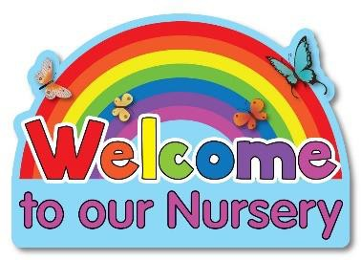

Our Nursery will be full-time from September 2026

We are delighted that Oakwood Integrated Nursery will be providing 26 FULL-TIME (8.45am – 1.15pm) NURSERY PLACES from September 2026.

(Please note that we operated staggered intake and settling-in period.)

